**MY WEB BROWSER**

Name : Kottedu Chandra Sekhar Avinash

Social Security Number:19980522T430

Course Code : ET1542

Date : 2020-11-24

I have done this Assignment with Siva Ganesh vaku

**Task A4 Summary :**Though the assignment has given example code the first tasks of the code has been implemented very easily and we have tried our own code in the TCP and UDP connections to check it has been worked well after that .I found out my PC’s IP number easily and inserted in the code as host number, As u told there was not any difference between “TCP Client.py” and “TCP Server.py”. Then I observed using Wireshark that is all, everything went well.

**Python Code From Task B1 :**

from http.server import HTTPServer, BaseHTTPRequestHandler

class Serv(BaseHTTPRequestHandler):

def do_GET(self):

if self.path == '/':

self.path = '/www.ingonline.nu/tictactoe/index.php?board=xoxoeoeex'

try:

file_to_open = open(self.path[1:]),read()

self.send_response(200)

except:

file_to_open = "File not found"

self.send_response(404)

self.end_headers()

self.wfile.write(bytes(file_to_open, 'utf-8'))

httpd = HTTPServer(('localhost', 80), Serv)

httpd.serve_forever()

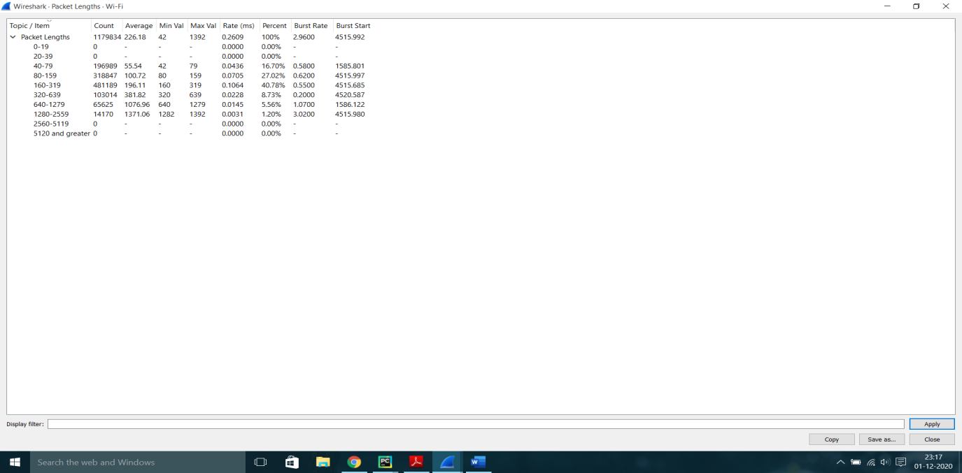

**HTML Code :**

|  |  |
| --- | --- |
|  | <html> |
|  |  |
|  | <head> |
|  | <TITLE>Tic-Tac-Toe</TITLE> |
|  | </head> |
|  |  |
|  | <body> |
|  |  |
|  | <b> Tic-Tac-Toe (3x3)</b><br> |
|  | <br><u>Before turn</u><br>x e e<br>o o x<br>x e o<br><br><br><u>After turn</u><br>e x e<br>o o x<br>x e o<br></body> |
|  | </html> |

**"Flow Graph" screenshot TASK B4a :**

**Packet content of the http request and http response TASK B4b,**

**(i.e. screenshot from Wireshark) :**

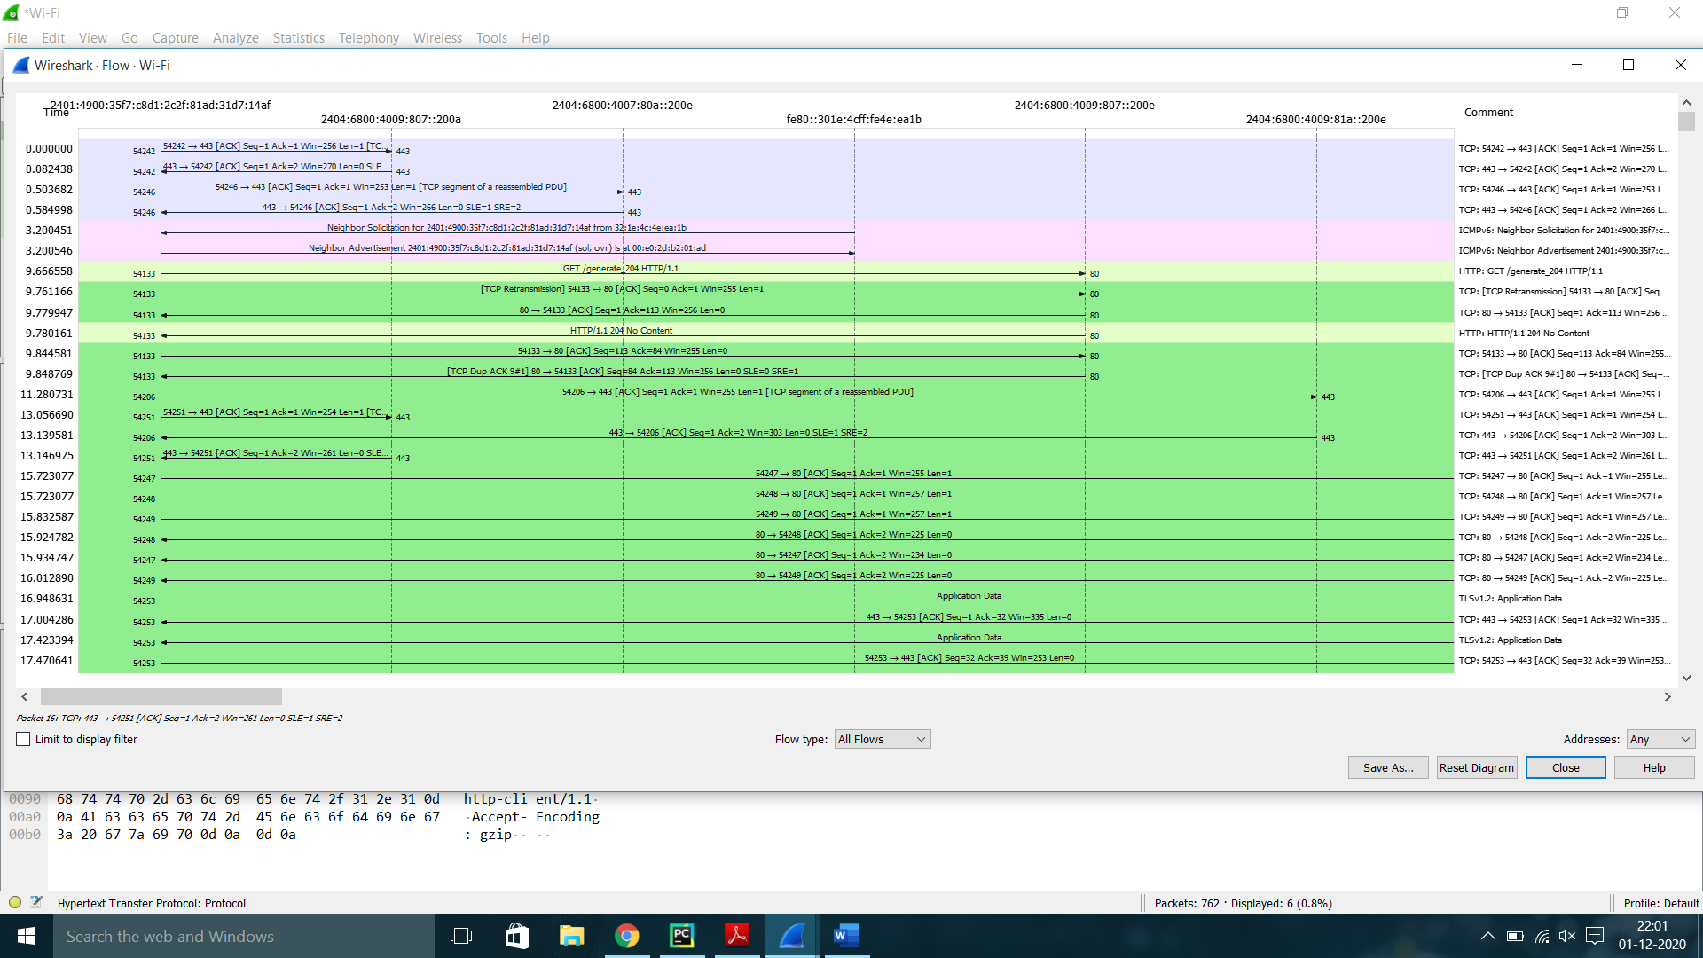

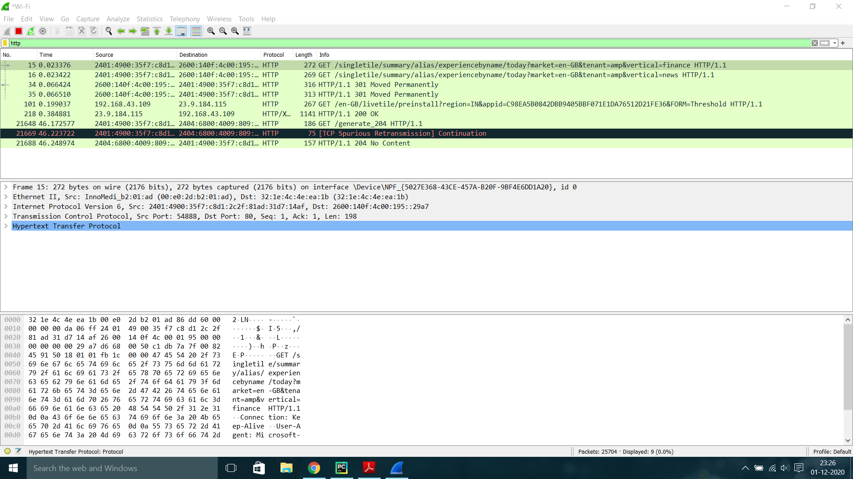

**Brief Summary of PART B :**With the code mentioned above, we created a HTTP to the given TIC TAC TOE server through the PORT 80. Then the program displayed HTTP request to the HTML, which included the response.

Now by using Wireshark software, by selecting http pack data, I captured the packet transmission, also the transmission in Flow Graph. Then pasted them here.